1.web component to an external endpoint is failing?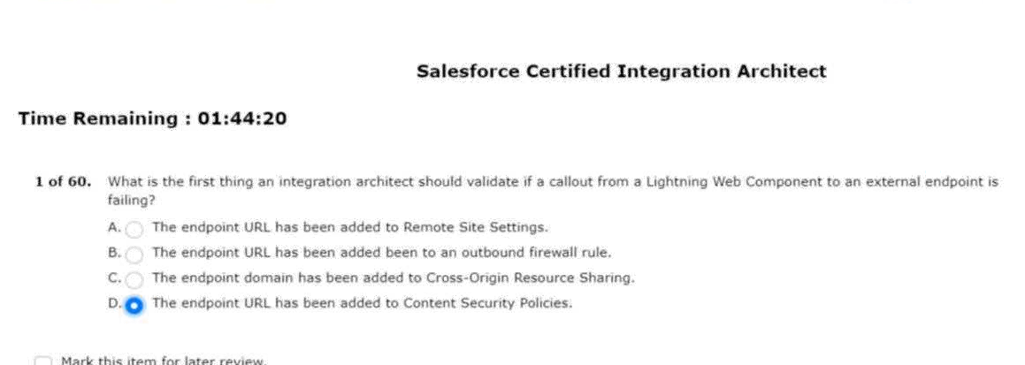
2.even when the client re-connects every couple of days. 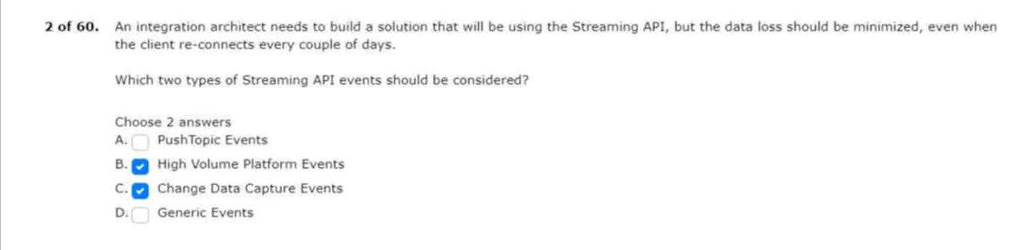
3.processes that salesforce supports are critical to the business.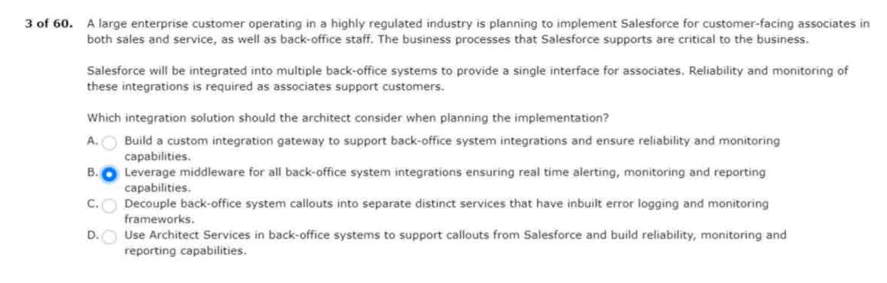
4.system landscape is planning to implement salesforce sales cloud.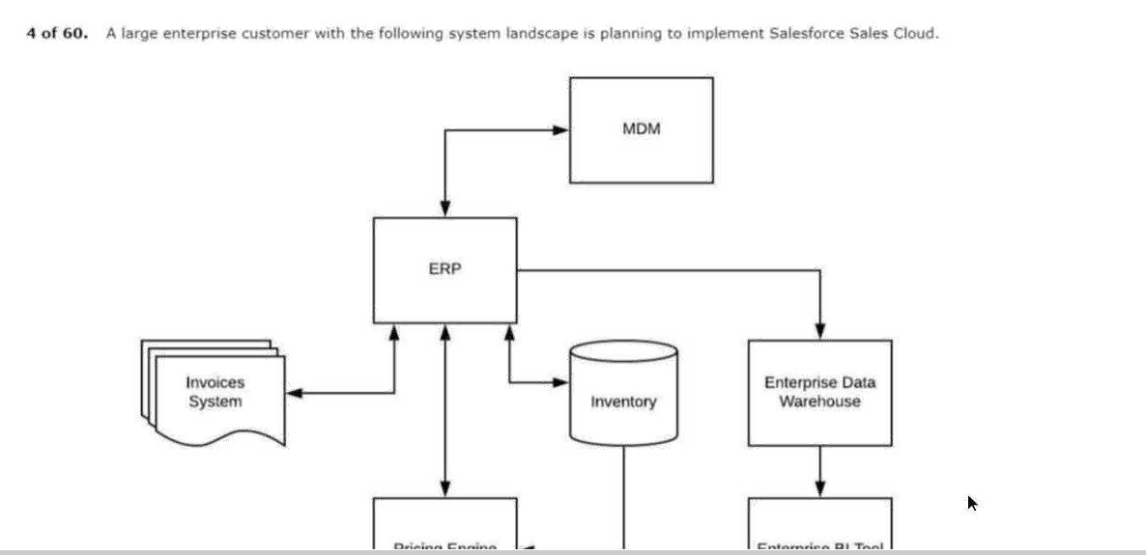
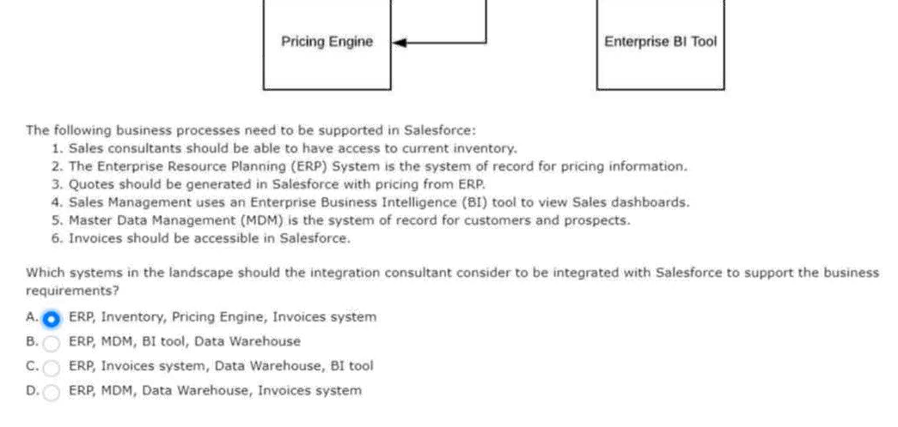

5.salesforce with an external system for a company.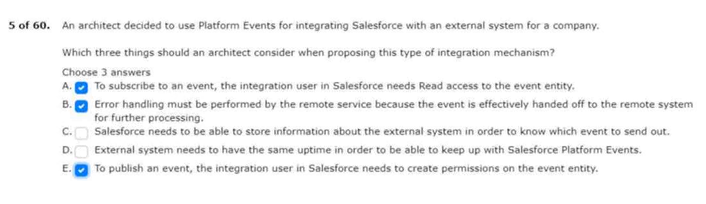
6.them to view the design files in the community.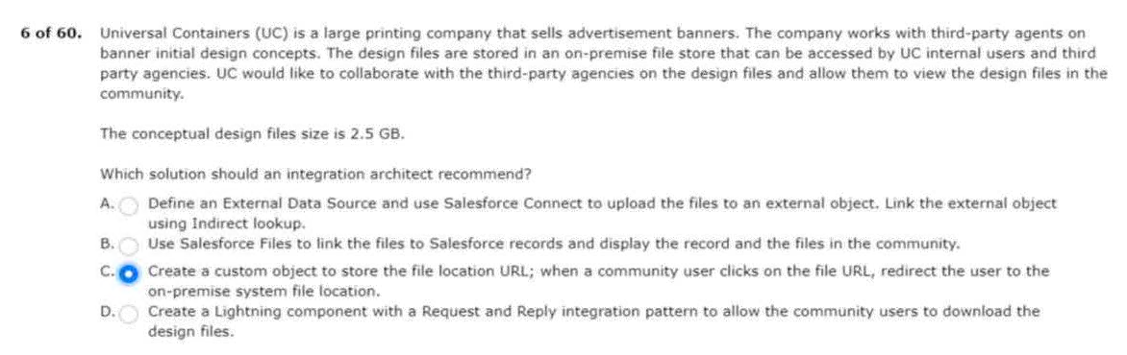
7.used in callouts from salesforce.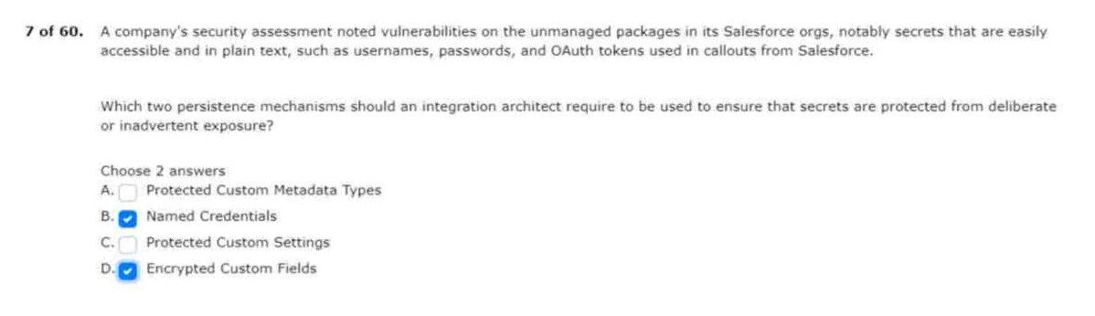
8.business critical function for end users.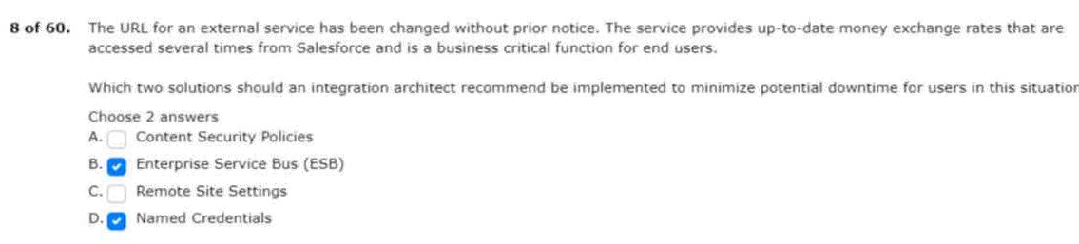
9.there will be approximately 1 million contacts per month.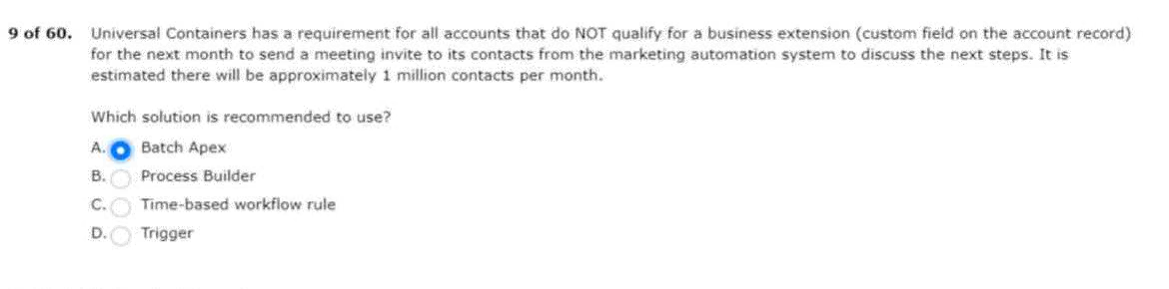
10.send orders from salesforce to a fulfillment system?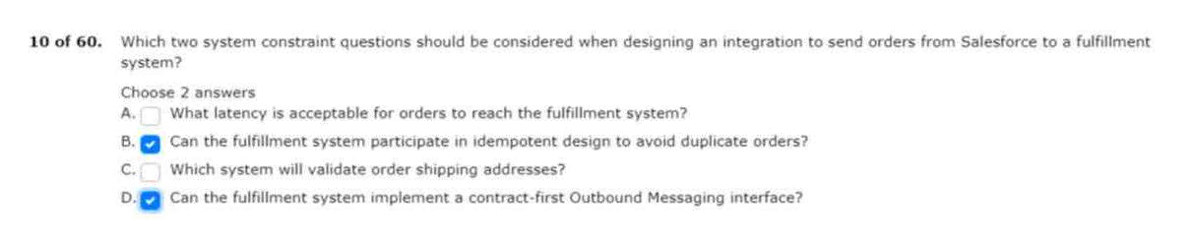
11.their current system landscape diagram.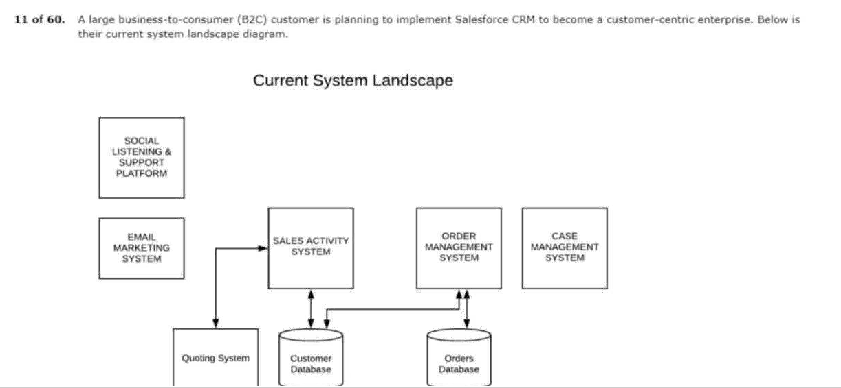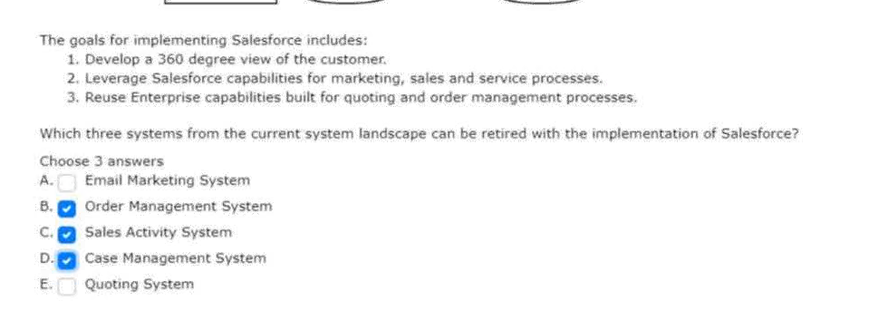
12.that masters all courses and student registration.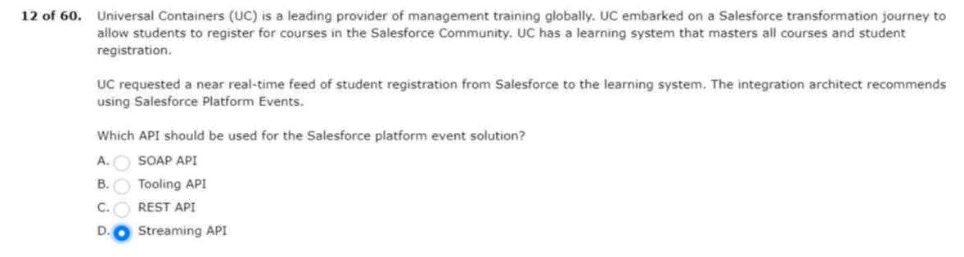
13.on the spot for customers who inquire about uc products.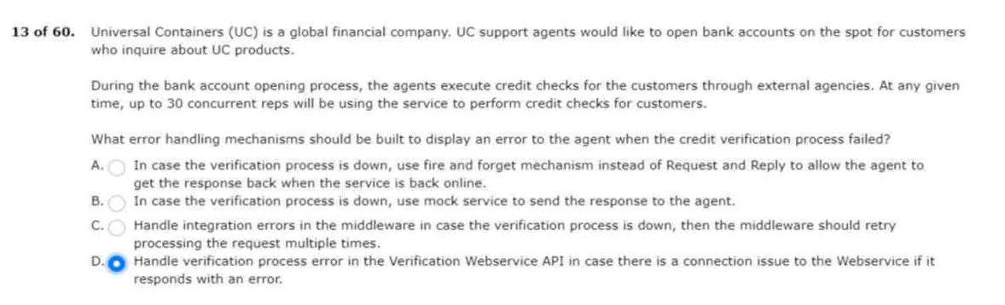
14.course registration data needs to be reflected in the lms.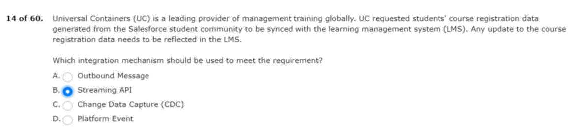
15.store them on a custom geolocation field.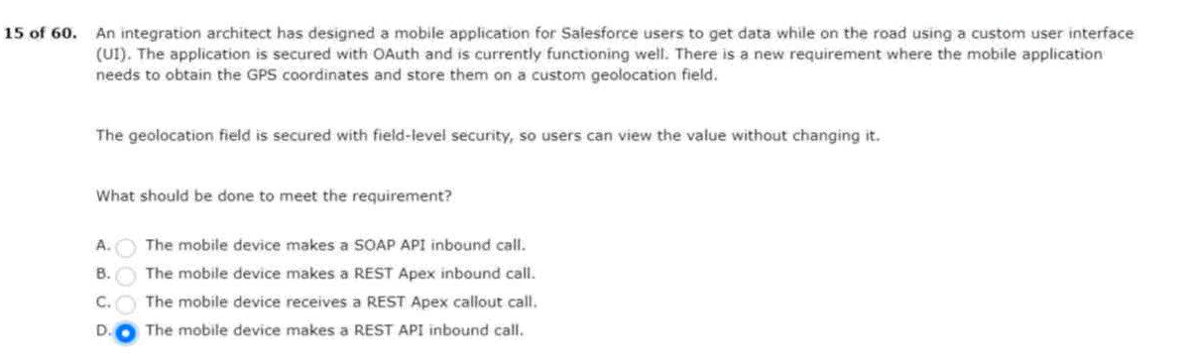
16.response back in a strongly-typed format.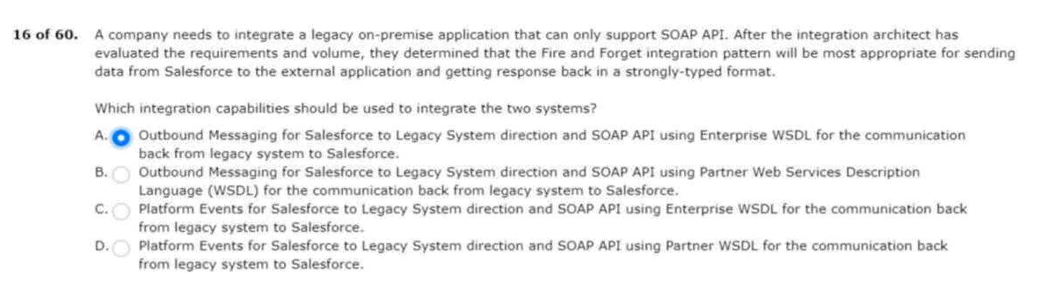
17.display the number of closed in real time.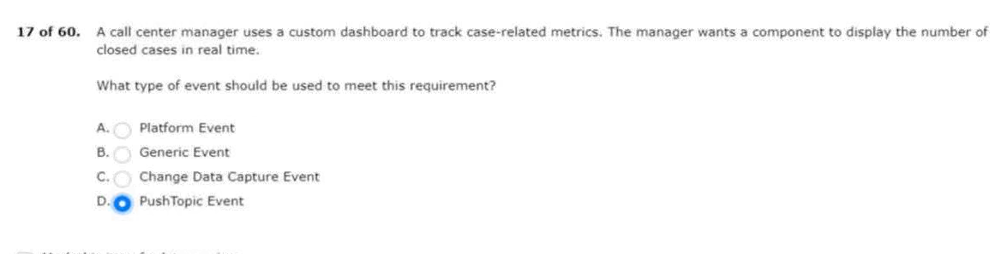
18.often experiences latency issues.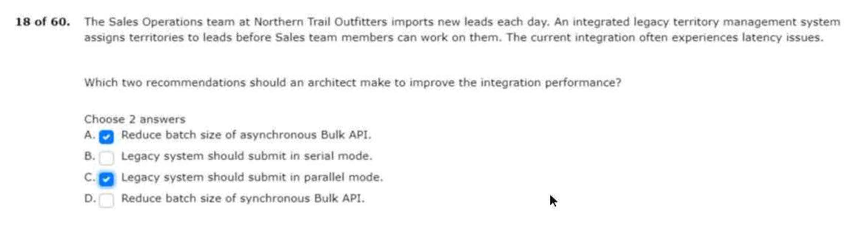
19.using rest api to avoid architecture changes.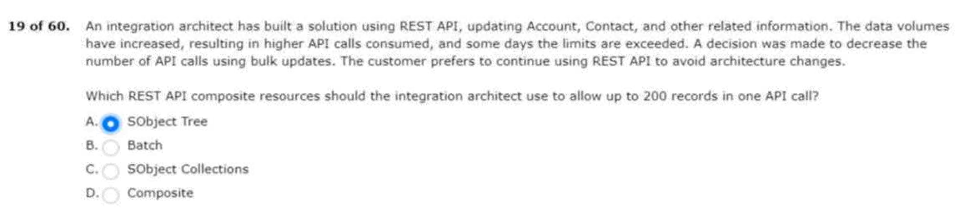
20.uses a soql query filtered by sharing hierarchy.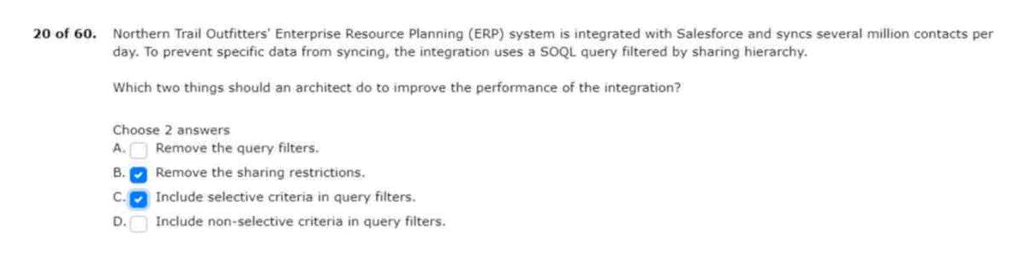
21.integrations from salesforce to on-premise servers.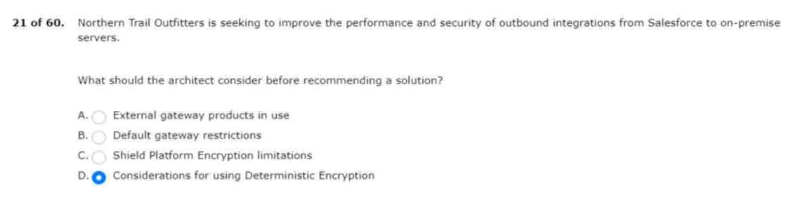
22.and request shipping estimates from that service.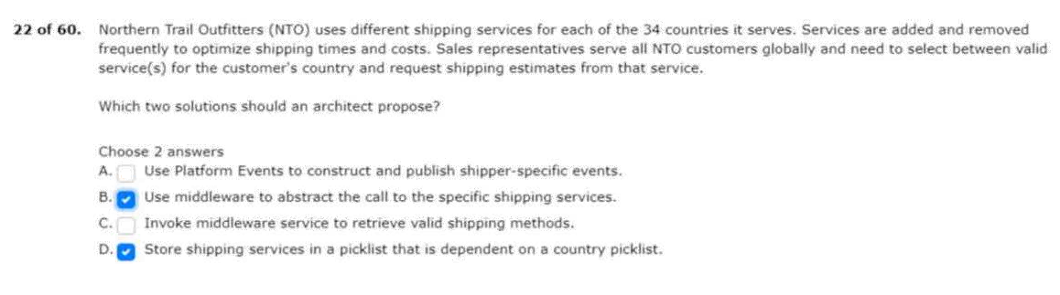
23.the following conditions exist: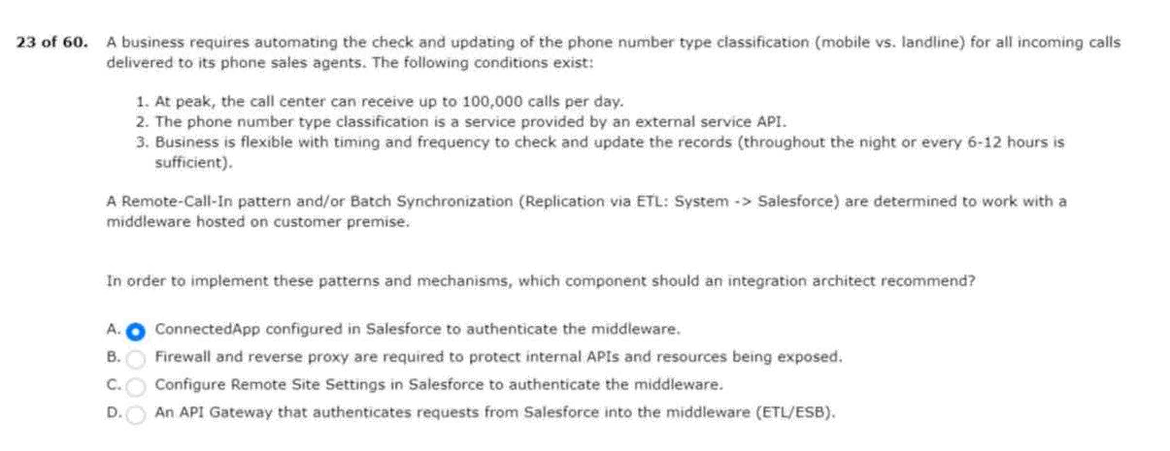
24.applications and plans to include salesforce as well.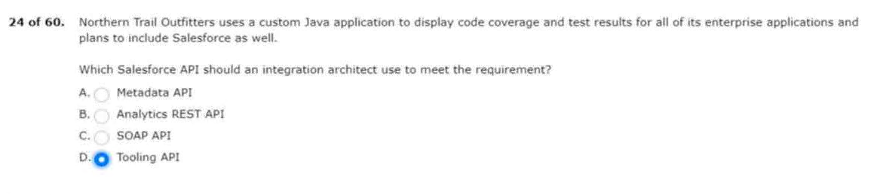
25.currently, uc has the following systems: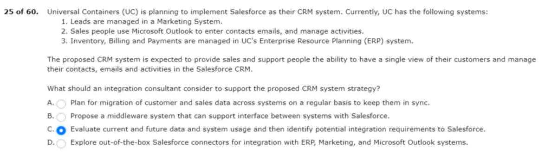
26.has the following systems and conditions in their landscape: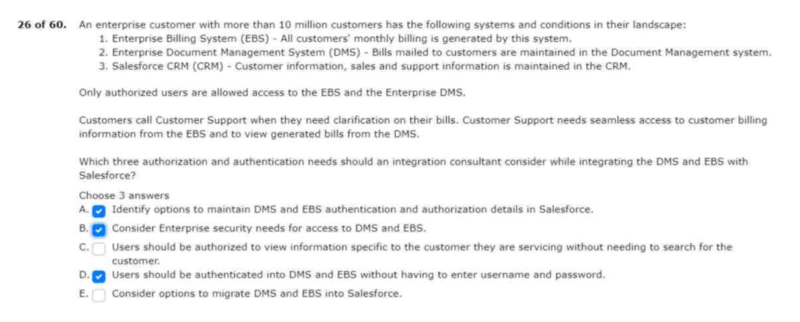
27.more than one salesforce org and different metadata?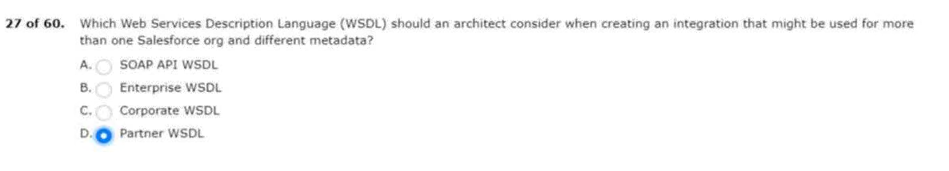
28.such aspects with their salesforce program.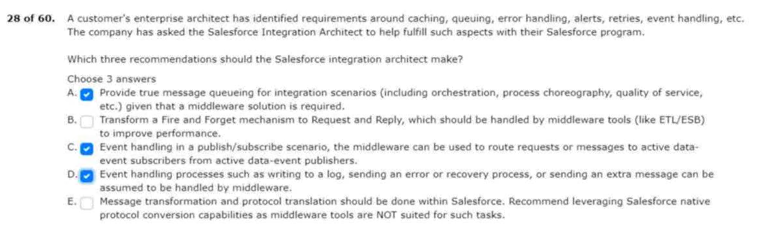
29.with an apex callout due to technical constraints.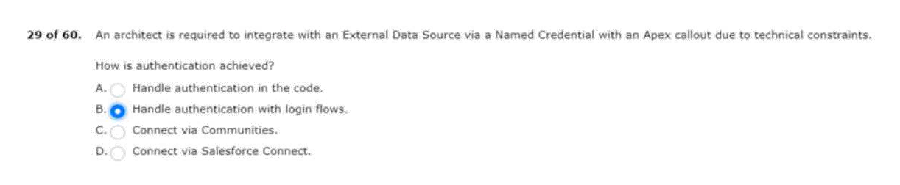
30.development resources and requires a low-code solution.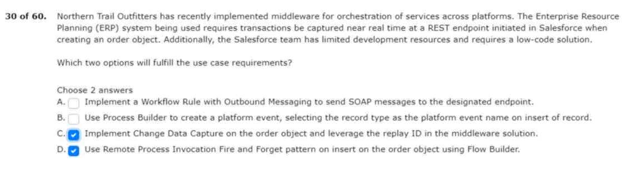
31.who are inquiring about uc bank accounts.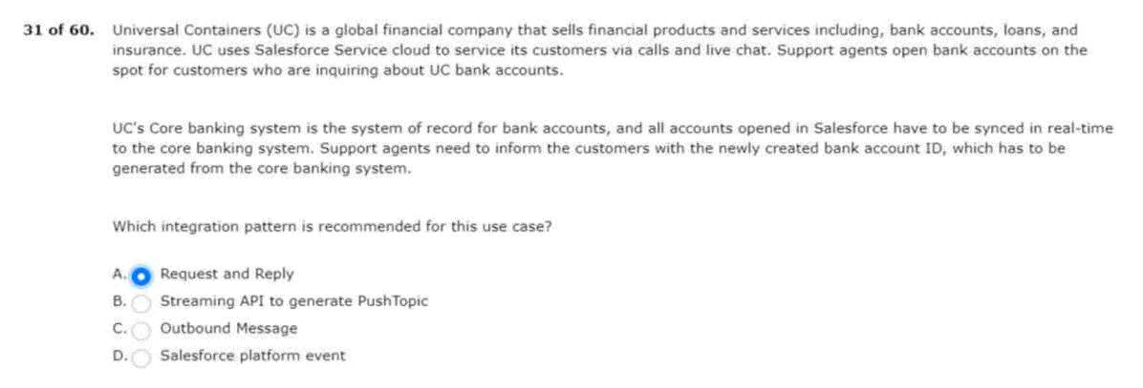
32.they will authorize installation of the package.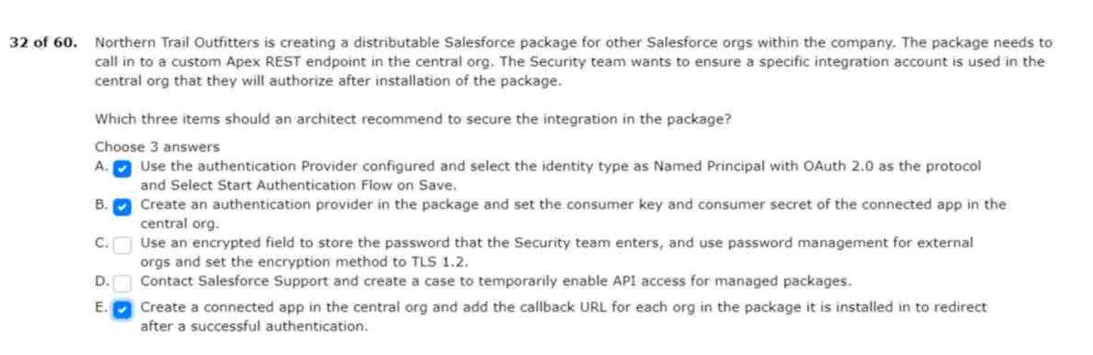
33.generates invoices from a given set of orders.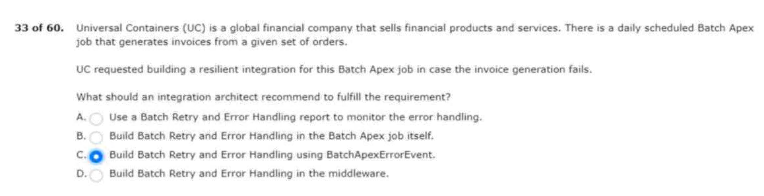
34.enterprise systems and salesforce platform limits.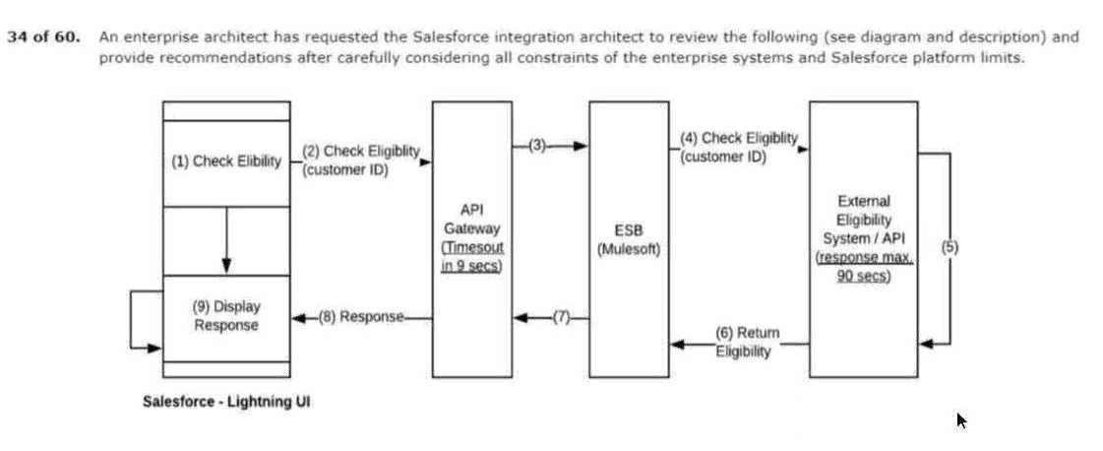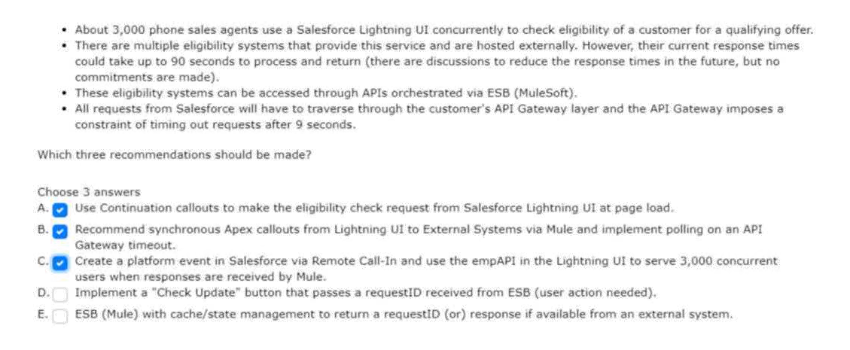
35.data enrichment processes in salesforce.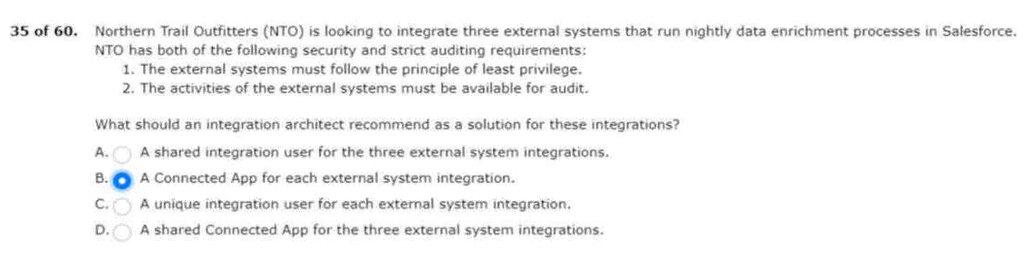
36.application should be kept synchronized for consistency.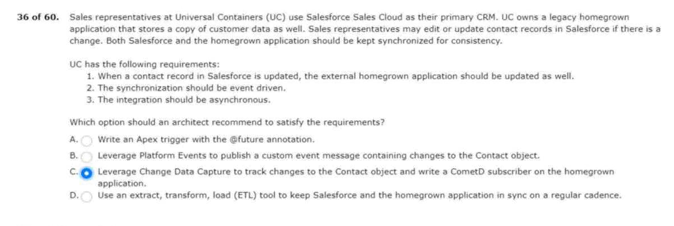
37.reserve inventory during customer checkout process.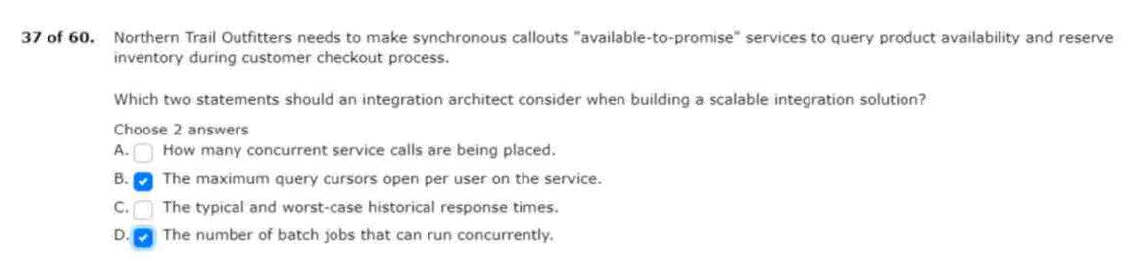
38.through self-registration and single sign-on (sso).

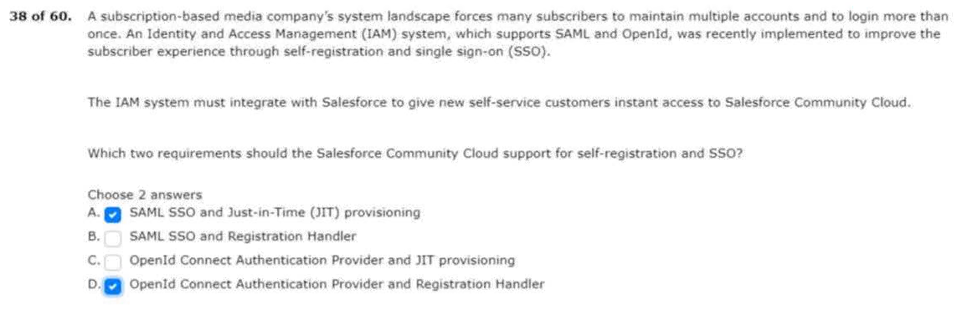
39.contracts that apex rest api clients can reply on.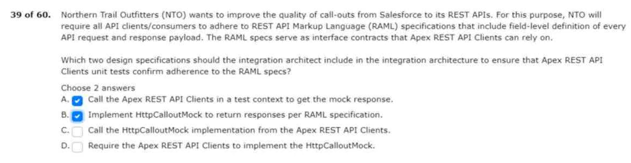
40.the students can retry the payment process.
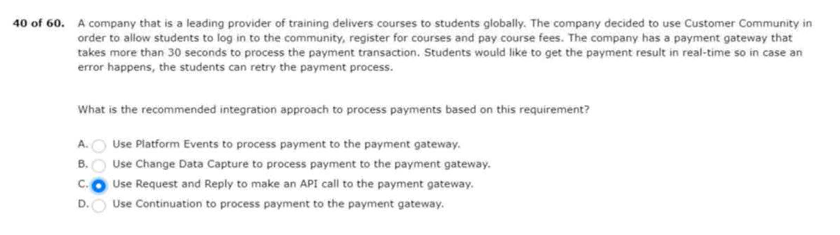
41.this system must remain on-premise.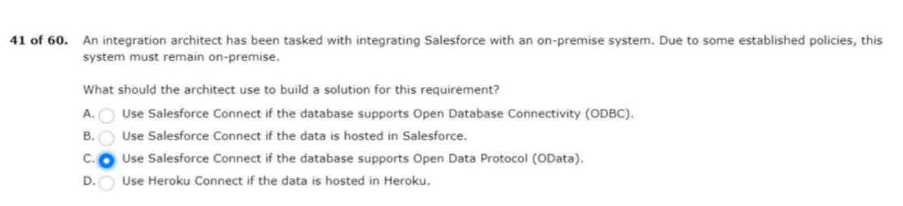
42.system will be taken down for maintenance.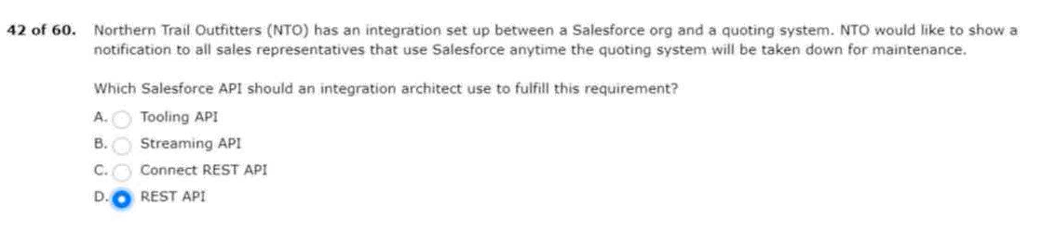
43.and keeps them synchronized via platform events.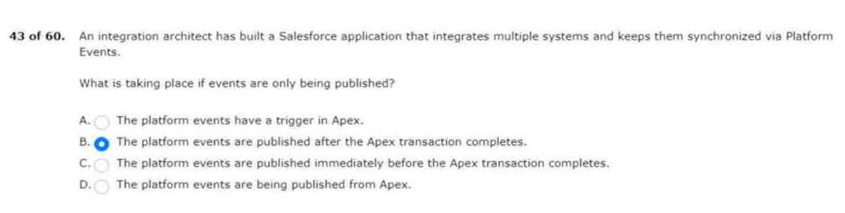
44.accounts using the lead-to-opportunity process.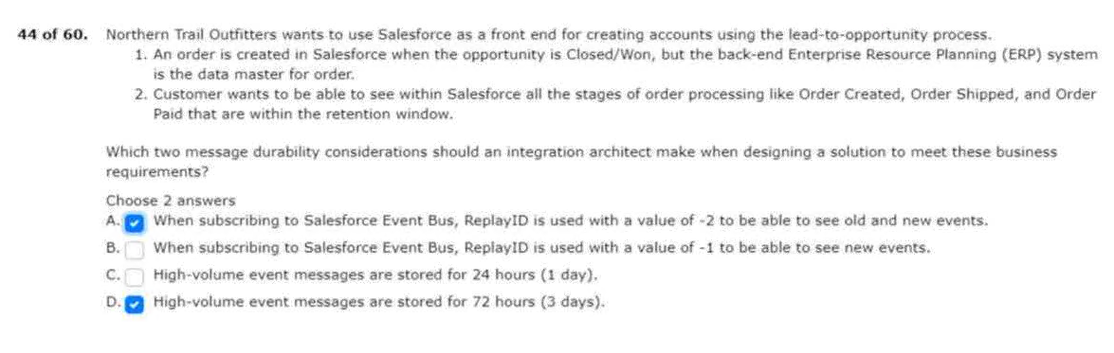
45.responding in boolean and string values data types.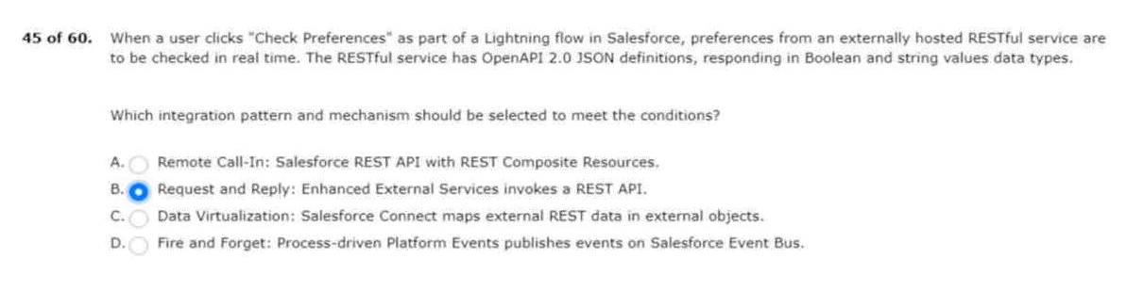
46.to notify any degradation in salesforce performance.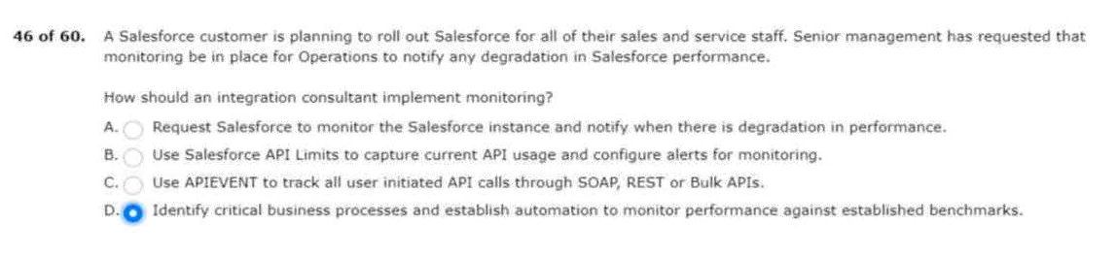
47.nto has the following requirements: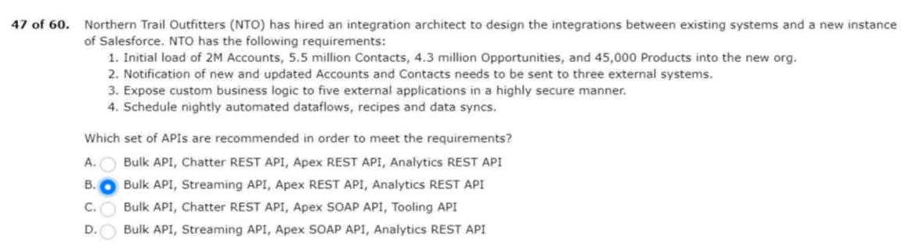

48.the events are as follows:
Will meet these business requirements?
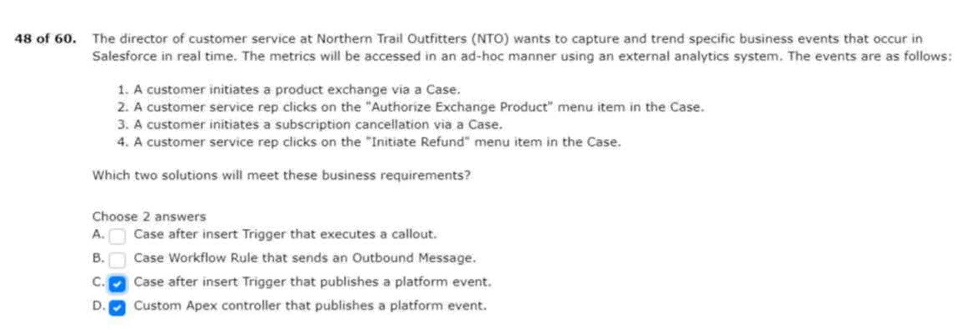
49.between their internal systems and salesforce.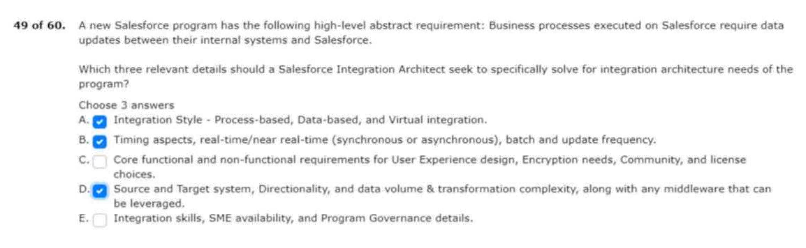
50.products and services that include the following: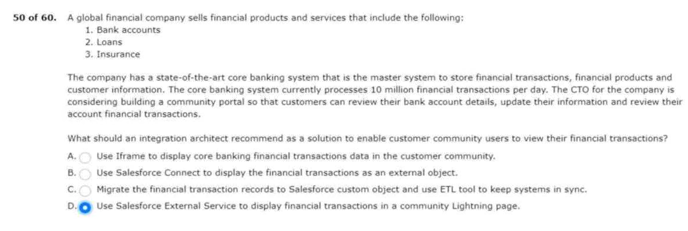
51.trail outfitters company portal use ssl mutual authentication? 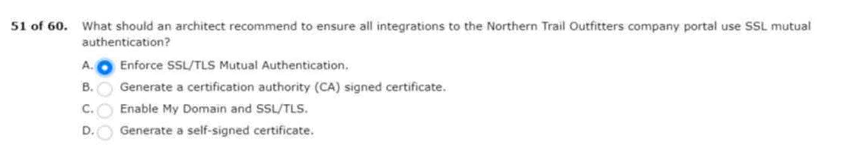
52.nto wants the data to only persist in the external system.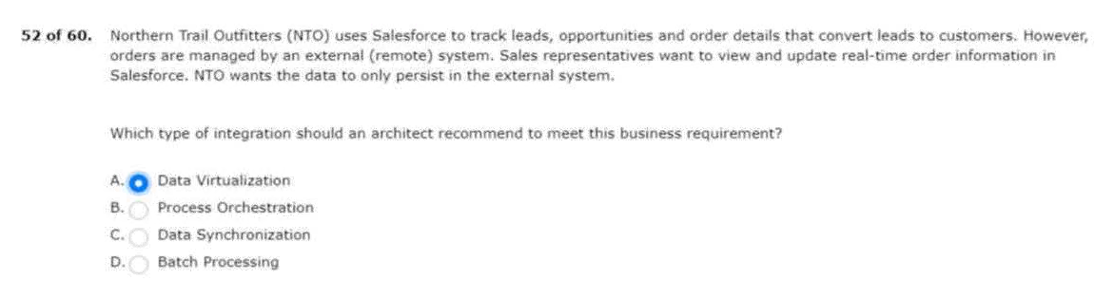
53.the current system landscape includes the following: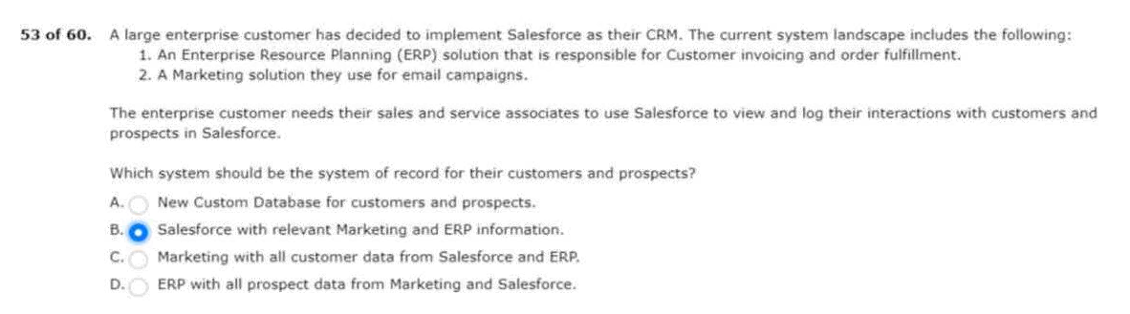
54.with limited outside access to external systems.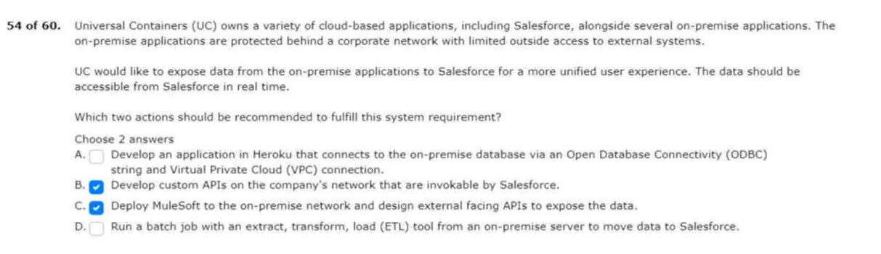
55.applications with on-premise resources and services.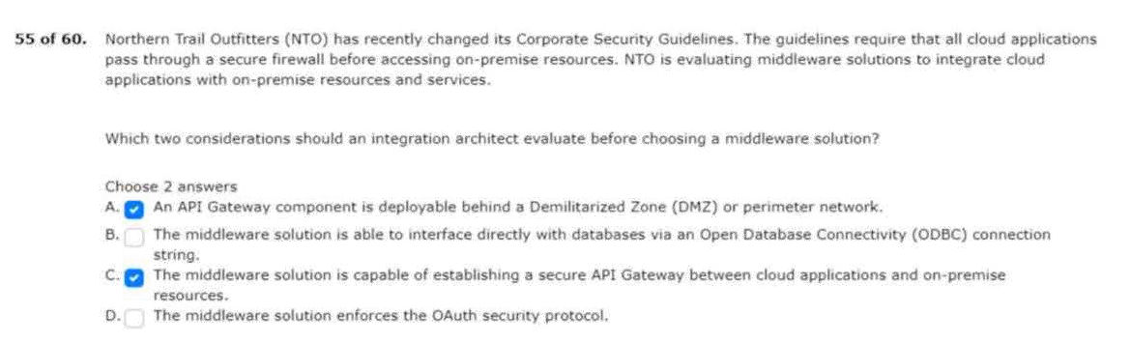
56.and asks the system architect for some guidance.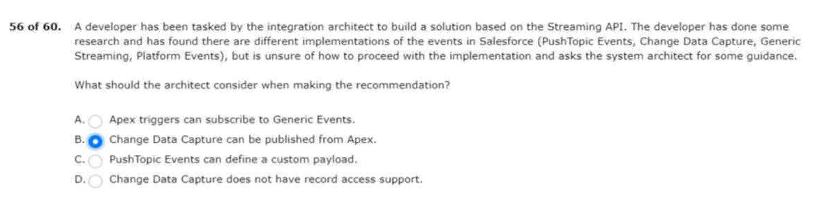
57.work with their legacy application with salesforce.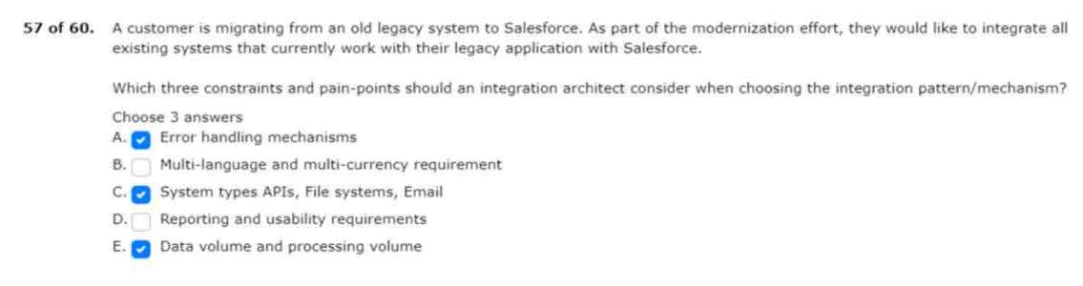
58.the company will complete the following: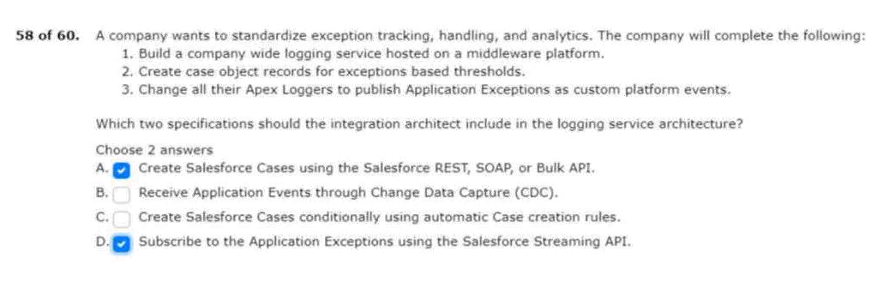
59.numbers in order to meet a business requirement.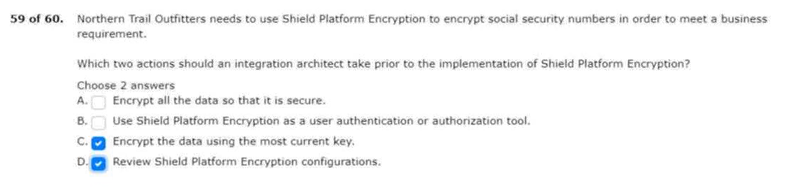
60.and has requested a solution recommendation.